Experiments:01

AIM : Design DFA to accept bcaaaaa , bc and c.

PROCEDURE:

1. Start the automata
2. Enter the states
3. Connect the respective nodes (states) and self loop.
4. Enter the inputs values in the named nodes .
5. Compile the execution with suitable inputs
6. Stop the executions.

Design input:

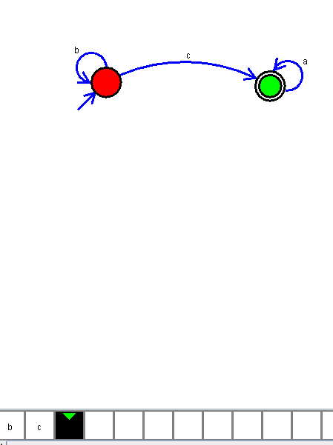

Output :

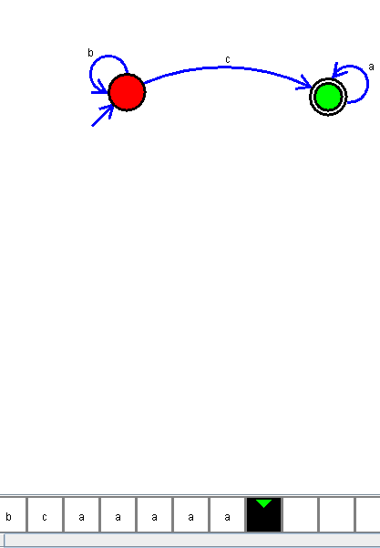

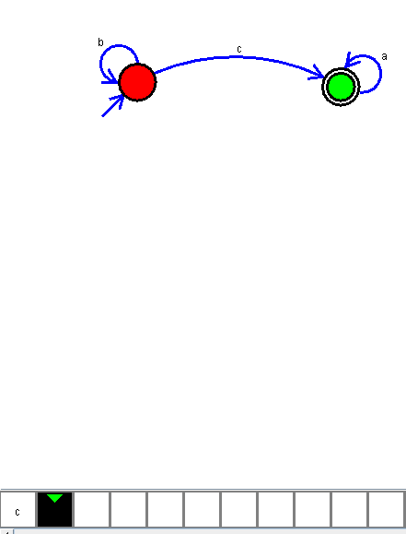

RESULT:

Thus the DFA design as been executed and implemented successfully.